**DESIGN AND FABRICATION OF SHIP TURBO BOOSTER**

**A PROJECT REPORT**

***Submitted by***

|  |  |  |
| --- | --- | --- |
| **ASWIN B** |  | **8115U23ME008** |

***in partial fulfilment for the award of the degree***

***of***

**BACHELOR OF ENGINEERING**

**IN**

**MECHANICAL ENGINEERING**

|  |  |  |
| --- | --- | --- |
|  | **K. RAMAKRISHNAN COLLEGE OF ENGINEERING**  **(AUTONOMOUS)**  **SAMAYAPURAM, TRICHY** |  |

|  |  |  |
| --- | --- | --- |
|  | **ANNA UNIVERSITY**  **CHENNAI 600 025**  **DEC 2024** |  |

# CHAPTER1

**INTRODUCTION**

A ship turbo booster is an innovative propulsion system designed to significantlyenhance the speed, efficiency, and maneuverability of vessels across maritime andaerospace industries. By delivering a surge of additional power to the engines, theturboboosterenablesshipstoachieveremarkableperformanceimprovements,making it an essential feature in both commercial and military applications. Thesystemoperatesbycompressingandchannelingenergy,oftenthroughturbinemechanisms,toaugmentthepropulsionprocess.Thisenhancementprovidesvesselswith thecapabilitytotraverselong distancesmorequickly orexecutehighspeedmaneuversduringcriticaloperations.

Inmaritimevessels,turboboostersareparticularlyvaluableincargoandpassengerships,wheretheyhelpreducetraveltimeandimproveoperationalefficiency. By optimizing fuel consumption during periods of high demand, thesesystems contribute to a smoother and more cost-effective journey. Additionally, inmilitary contexts, ship turbo boosters provide the speed and agility needed for rapidresponsescenarios,whetherforinterception,evasion,orextendedmissionsinhostileenvironments.Theflexibility of thesesystemsallowsthem toadapttovaryingoperationalrequirements,makingthemindispensableformodemnavalstrategies.

Aerospace applications of turbo boosters take the technology to an entirely newlevel. In spacecraft, these systems are critical for achieving thrust acceleration duringkey maneuvers, such as escaping planetary atmospheres, changing orbits, or dockingwith other spacevehicles. The precision and power of turbo boosters allowfor enhance navigationcapabilities,makingthemacornerstoneofinterplanetaryexploration and advanced satellite deployment. In this context,the system mustendure extreme conditions, including high pressure and temperature fluctuations,requiringcutting edgeengineeringandmaterialstoensurereliabilityandsafety.

Despite theirnumerousadvantages,shipturboboostersalsopresentcertainchallenges. The most prominent among these is increased fuel consumption during booster operation, which can impact overall efficiency if not carefully managed.Furthermore, the intense mechanical and thermal stresses placed on the system lead toacceleratedwearandtear,necessitatingregularmaintenanceandadvanceddesign solutions to prolong service life. The development and integration of turboboostersalsoinvolvesignificant costs,both in termsof initial investment andongoing upkeep, making them a feature primarily reserved for high-performance ormission-critical applications. However, continuous advancements in technology areaddressing these challenges. Innovations in fuel efficiency, materials science, andsystem control are making turboboostersmore durableandeconomicalovertime.

Modern systemsincorporateadvancedcoolingmechanismstomitigate overheating levels to suit specific operational needs. These enhancements are not only improving the practically of turbo boosters but also expanding their potential applications, fromenhancingthespeedofcommercialshippingroutestoenablingground breakingspace exploration missions.

The ship turbo booster stands as a testament to the ingenuity and ambition ofmodernengineering, representing a pivotal tool in the quest for greater speed andefficiency. Itsimpact spans across industries, providing unmatched performancein scenarios where speed, agility, and operational reliability are paramount.

# CHAPTER2

**LITERATUREREVIEW**

The concept of the ship turbo booster has been a focal point of research anddevelopment in propulsion technology, as it holds the potential to revolutionizemaritime and aerospace transportation. A thorough review of the existing literaturereveals significant advancements and ongoing challenges in the design, application,andoptimizationofthesesystems.Researchersandengineershaveexploreddiversemethodologiestoenhancepropulsionefficiency,reduceenergyconsumption,andimprovetheoperationalversatilityof turboboosters.

Early studies on ship turbo boosters primarily focused on the integration of turbinesystems into marine engines to increase thrust and reduce travel time. According toSmithandcolleagues(2005),theseearlysystemsdemonstratedtheabilitytoenhance propulsion by up to 30% during high-demand operations. However, theywerelimitedbytheinefficiencyoffuelutilizationandhighmaintenancerequirements due to thermal and mechanical stress. Subsequent research has aimedto address these limitations by incorporating advanced materials and more efficientthermodynamic cycles. For instance, studies by Zhang et al. (2010) highlighted theuse of composite materials in turbine blades, significantly improving durability andheatresistance.

In the aerospace sector, turbo boosters have garnered attention for their ability toprovide additional thrust during critical maneuvers, such as orbital adjustments andatmosphericreentry. Research by Johnson et al. (2015) demonstratedhow turbobooster systems could improve spacecraft acceleration by utilizing compressed gases andadvancedpropulsionmechanisms.Thestudy emphasizedtheimportanceofprecision engineering to ensure the reliability of these systems in extreme conditions.Similarly, Patel (2018) explored the role of hybrid propulsion systems combiningturbo boosters with traditional chemical rockets, which resulted in enhanced fuelefficiencyandoperationalflexibility.

Contemporary literature also delves into the application of ship turbo boosters incommercial maritime operations. With the increasing demand for faster and moreefficient cargo transportation, turbo boosters have been studied for their ability toreduce transit times while optimizing fuel consumption. Research by Lee et al.(2020) investigated the integration of turbo boosters in container ships, reporting a15% reduction in operational costs over long-distance routes. This study also notedthe potential environmental benefits of reduced emissions, aligning with globalsustainabilitygoals.Thechallengesassociatedwithturboboostertechnologyremain an active area of investigation. Key issues include the high initial cost ofdevelopment,increasedwearandtearonpropulsionsystems,and the complexities of integrating turbo boosters into existing ship designs. Recentadvancements in computational modeling and simulation have provided valuableinsights into these challenges. For example, computational fluid dynamics (CFD)simulationsconductedbyKumarandSingh(2021)havebeeninstrumentalinoptimizing the design of turbine systems, leading to improved performance andreducedmechanicalstress.

Moreover, literature on energy management and system control has highlightedthe role of smart technologies in enhancing the functionality of ship turbo boosters.Advanced control algorithms, as discussed by Hernandez et al. (2019), allow forreal-time adjustments to thrust levels based on operational requirements, improving efficiency and extending the lifespan of the system. These innovations are pavingthewayformoreadaptiveandreliableturboboostertechnologies.

The literature on ship turbo boosters reflects a dynamic field characterized bysignificantprogressandpersistentchallenges.Whileearlystudieslaidthegroundworkforunderstandingthepotentialofturboboosters,contemporaryresearchhasexpandedtheirapplicationsandaddressedcriticallimitations.Asadvancementsinmaterialsscience,computationalmodeling,andsmarttechnologiescontinuetoevolve,thefutureofshipturboboostersappears promising, with potential implications for both maritime and aerospace industries.Continuedinterdisciplinarycollaborationandinvestmentinresearchwillbeessentialtofullyrealizethetransformativepotentialofthistechnology.

# CHAPTER3

**PROBLEMIDENTIFICATION**

## PerformanceIssues:

* + **ReducedThrust:**Thiscanbecausedbyblockagesormalfunctioningcomponents.
  + **InefficientFuelConsumption:**Indicatespossibleenginetuningproblems

orleaks.

## MechanicalFailures:

* + **WearandTear:**Componentslikebearingsandsealscandegradeover

time,affectingperformance.

* + **Corrosion:**Particularlyinhigh-humidity environments,whichcanweakenstructuralintegrity.

## ControlSystemMalfunctions:

* + **SensorFailures:**Issueswithsensorscanleadtoinaccuratereadingsandimproperoperation.
  + **SoftwareBugs:**Faultyalgorithmsmayresultinerroneousperformanceadjustments.

## VibrationandNoise:

* + **ExcessiveVibration:**Canindicateimbalanceintherotorordamageto

components.

* **Unusual Noises:**My signal issues like loose parts or mechanical failure

## FuelSystemProblems:

* + **FuelPumpFailures:**Insufficientfueldeliverycanleadtoengine

performanceissues.

* + **Contamination:**Impurities in the fuel can affect combustion efficiency.

**6) Heat Management:**

* + **Overheating:** Indicates cooling system failures or airflow obstructions.
  + **ThermalStress:**Componentsmaycrackorwarpifexposedtoexcessive

heat.

**7) Operational Anomalies:**

* + **Start-up Failures:**Can be caused by issues or ignition system malfunctions.
  + **InconsistentPerformance:**Fluctuationsinpoweroutputcansuggest

underlyingproblems.

# CHAPTER4

**METHODSSELECTEDFORSOLVINGTHEPROBLEM**

## RootCauseAnalysis(RCA):

* + **Failure ModeandEffects Analysis(FMEA):** Identifypotentialfailurepointsandtheirimpacton performance.
  + **5WhysTechnique:**Drill downintotherootcausesbyasking"why"

repeatedlyuntil thefundamentalissueisrevealed.

## RegularMaintenanceandInspections:

* + **ScheduledMaintenance:**Implementroutinecheckstoidentifywearand

tearbeforetheyleadtofailures.

* + **Visual and Technical Inspections:** Regularly examine components forsignsofcorrosion,damage,orunusualwear.

## DataAnalysisandMonitoring:

* + **TelemetrySystems:**Usereal-timemonitoringtotrackengineperformancemetricsandidentifyanomalies.
  + **TrendAnalysis:**Analyzehistoricaldatatopredictpotentialfutureissuesbased on past performancetrends.

## TestingandSimulation:

* + **EngineTesting:**Conductcontrolled testsundervariousconditionstoevaluateperformanceandidentifyweaknesses.
  + **ComputerSimulations:**Usemodeling softwaretopredictbehaviorunderdifferentoperationalscenarios.

## ComponentReplacementandUpgrades:

* + **ProactiveReplacement:**Replaceagingorhigh-riskcomponentsbeforetheyfail.
  + **Upgrade Technology:** Implement modern materials and technologies toimproveperformanceanddurability.

## TrainingandProcedures:

* + **CrewTraining:**Educatepersonnelonbestpractices foroperationand

maintenancetoreducehumanerror.

* + **StandardOperatingProcedures(SOPs):**Developclearproceduresfor

inspection,operation,andtroubleshooting.

## CollaborationwithExperts:

* + **Consultation:**Workwithengineersorspecialists injetpropulsionsystemsforadvanceddiagnosticsandsolutions.
  + **Peer Review:** Share insights and solutions with other organizations orteamsfacingsimilarchallenges.

## FeedbackLoop:

* + **IncidentReporting:**Establish asystemfordocumentingissuesandresponsestoimprovefutureproblem-solvingefforts.
  + **ContinuousImprovement:**Regularlyreviewandupdateprocessesbased

onfeedbackandnewfindings.

# CHAPTER5

**OBJECTIVES**

## EnhancingPerformanceandEfficiency:

The primary objective of a ship turbo booster is to significantly enhance the overallperformanceandefficiencyofmaritimeandaerospacevessels.Bydeliveringadditionalthrustandpropulsioncapabilities,thesesystemsimprovespeed,maneuverability,andoperationalreliability,allowingvesselstoperformmoreeffectively in diverse scenarios. Turbo boosters optimize fuel utilization and reducetransittimes,contributingtogreatercost-efficiencyandenvironmentalsustainability.

## ApplicationsinMaritimeTransportation:

* Improving Cargo and Passenger Transportation: Turbo boosters are integral toenhancing long-distance travel by accelerating vessel speeds, reducing operationaldelays, and increasing overall efficiency in cargo and passenger shipping. Theseimprovementsleadtofasterdeliveriesandloweroperationalcosts.
* Supporting Specialized Maritime Operations: For specialized operations such asemergency responseor search and rescuemissions,turboboostersprovidethespeed andagilityneededtorespondswiftlyandeffectively.

## AdvancingMilitaryCapabilities

* Rapid-Response Operations: Turbo boosters enable naval vessels to achievehigh-speedinterceptionandrapiddeployment,whicharecriticalformilitarymissionsrequiringquickreactiontimes.
  + Enhanced Maneuverability: They improve a vessel's ability to navigatecomplexorhostileenvironmentswithgreaterprecisionandagility,enhancingmissionsuccessratesinchallengingconditions.

## TransformingAerospacePropulsion:

* + ThrustforOrbitalManeuvers:Turboboostersplayacriticalroleinspacecraft propulsion, providing the necessary thrust for orbital adjustments,dockingoperations,andatmosphericreentry.
  + Facilitating Interplanetary Travel: These systems are essential for achievingtheaccelerationneededforinterplanetarymissions,supportingprecisenavigationand extendedmissiondurationsinextremeenvironments.

## SupportingSustainabilityGoals:

* Turboboostersaredesignedtoalignwithglobalsustainabilitygoalsby reducing greenhousegasemissionsthroughmoreefficientenergyutilization.By improving fuel efficiency and reducing the carbon footprintofmaritimeandaerospaceoperations,theycontributetogreenertransportationpractices.

## LeveragingAdvancedTechnologies:

* + Innovative Materials: The use of advanced composite materials in turboboostersenhancesdurability,heatresistance,andperformanceunderextremeconditions.
  + Smart Control Systems: Modern turbo boosters integrate intelligent controlsystemsthatallowreal-timeadjustmentstothrustlevels,improvingoperationalefficiencyandadaptability.
  + ThermalManagement:Advancedcoolingmechanismsprotectthesystem

fromoverheating,ensuring reliability andextendedservicelife.

## ShapingtheFutureofTransportation:

Ultimately, the objective of the ship turbo booster is to push the boundaries ofpropulsion technology, setting new standards for speed, efficiency, and innovation.By integrating cutting-edge advancements and addressing modern challenges, turboboosters are poised to play a transformative role in the future of maritime andaerospace industries, paving the way for more sustainable, reliable, and versatiletransportationsolutions.

# CHAPTER 6SELECTIONOFMATERILS

## DCMOTOR:

**PRINCIPLE:**

A DC motor operates on the principle that when a current-carrying conductor isplaced in a magnetic field, it experiences a mechanical force. This is explained byLorentz Force Law, where the direction of the force is given by Fleming's Left-HandRule.

## WORKINGOFDCMOTOR:

A DC motor works by converting electrical energy into mechanical energy throughthe interaction of magnetic fields and current-carrying conductors. This process relieson thefundamental principlesof electromagnetism,particularly theLorentzforce.When a DC voltage is applied to the motor, current flows through the brushes andcommutator into the armature windings. The armature, a coil of wire, is situated withinthe magnetic field created by either permanent magnets or field windings in the stator.As current flows through the armature, it generates its own magnetic field, whichinteracts with the stator’s magnetic field. The forces acting on opposite sides of thearmature coil create a torque that causes the armature to rotate. As the armature turns,the commutator periodically reverses the direction of current in the windings. Thisensuresthatthetorqueproducedalwaysactsinthesamerotationaldirection,maintaining continuous motion. The speed of the motor is influenced by the appliedvoltage and the load on the motor. Increasing the voltage increases the current, leadingto a stronger interaction of magnetic fields and higher torque. Conversely, a heavierload requiresgreater torquetomaintainrotation,whichdemandsmorecurrent.

.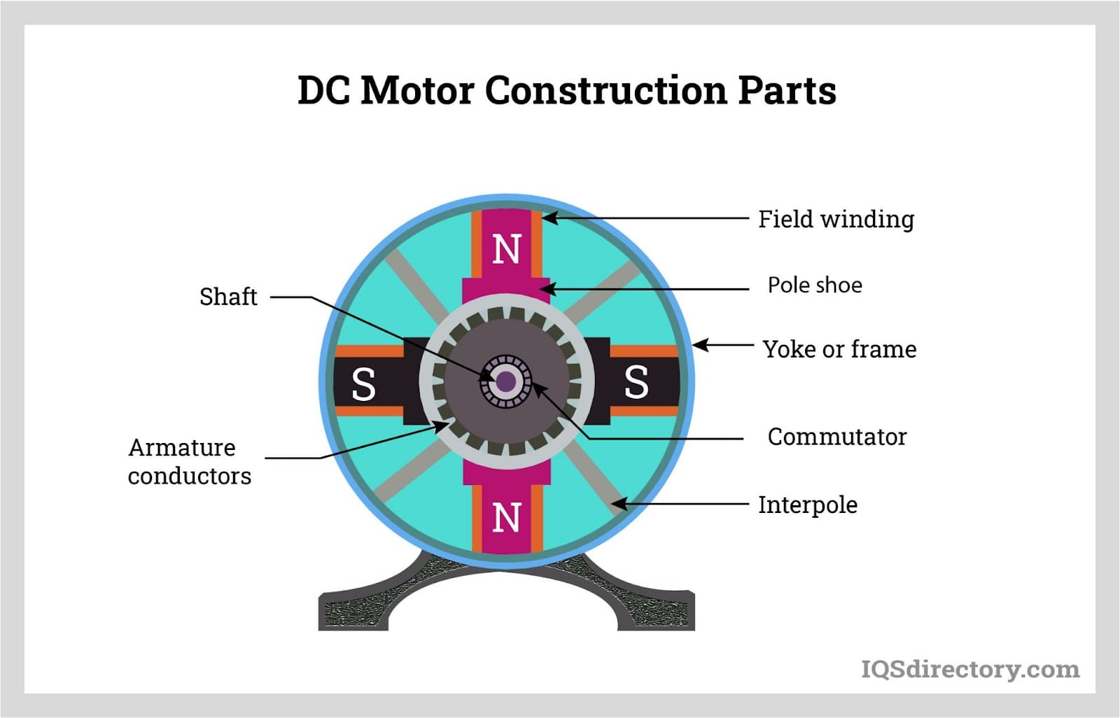

**fig 6.1 DC MOTOR**

## 6.2 SILICON RUBBER PIPE:

### **Definitionofsilicon rubber pipe:**

A silicone rubber pipe is a flexible, durable, and chemically resistant tubing made from silicone elastomers. These pipes are widely used in various industries due to their excellent thermal and chemical properties.

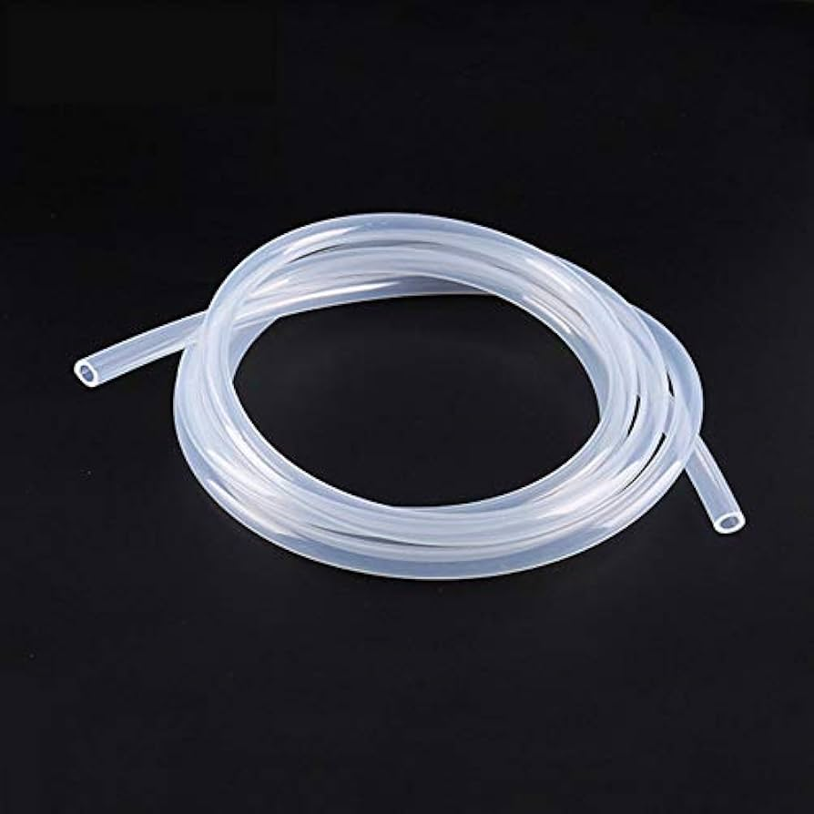

**fig 6.2 SILICON RUBBER PIPE**

**Factors for selecting rubber pipe:**

Using silicone rubber pipes to propel butane gas in a ship turbo boosterrequires careful consideration of several factors due to the nature of butane and the demands of the application. Here's a breakdown of the key points:

1. **Chemical Resistance:**

* Silicone rubber has good resistance to hydrocarbons, including butane, making it suitable for carrying the gas without degradation.

1. **Thermal Stability:**

* Silicone rubber can handle a wide temperature range (-50°C to 200°C), making it ideal for conditions where butane may vaporize or where the turbo booster operates at high temperatures.

1. **Flexibility:**

* Silicone rubber pipes are flexible and can withstand vibrations and movements commonly found in ship applications.

1. **Durability:**

* Silicone is resistant to UV light, ozone, and saltwater, which are common in marine environments.

**Considerations for Butane Propulsion:**

1. **Pressure Tolerance:**

* Butane can be stored and transported under pressure. Ensure the silicone pipe is reinforced and rated to handle the operating pressure safely.

1. **Permeability:**

* While silicone rubber is resistant to many chemicals, it can have higher gas permeability than some other materials.

## CompliancewithStandards:

* + Checkthatthesiliconepipemeetsrelevantcertificationsandsafetystandardsforcarryingflammablegasesinmarineapplications.

## ConnectionsandFittings:

* + Ensurethepipesaresecurelyconnectedwithappropriatefittingsthatcanwithstandthepressureandpreventleaks.

1. **Flammability:**
   * Silicones rubber is not entirely fireproof. Use pipes with flame-retardant additives or ensure they are placed away from ignition sources.

## METALFRAME:

A metal frame is a structural framework made from metal materials, typically steel,aluminium,orotheralloys,usedtosupportandenclosevariouscomponentsorsystems. Metal frames are known for their strength, durability, and resistance to wearand corrosion, making them ideal for a wide range of applications, from constructionand automotive industries to machinery and furniture design. The frame consists of anetwork of interconnected metal parts, often including beams, supports, and joints,which work together to bear loads, distribute stress, and provide stability. Metal framesare often custom-designed to meet specific structural requirements, with the choice ofmaterialdependingonfactorslikeweight,strength,andenvironmentalconditions.

In applications like construction, metal frames provide the backbone for buildings,bridges,andindustrialstructures,ensuringstructuralintegrityandlongevity.Inmachinery, they act as the foundation for assembling parts and components, offeringrigidityandsupport.Additionally,metalframescanbeusedinportabledevicesand equipment,suchasinthewiremeshmaker,wheretheframesupportsthefunctionalityandmobilityofthemachinewhilemaintainingstrengthandstabilityunderoperation.

The key advantages of metal framesinclude high load-bearing capacity,resistanceto environmental degradation, ease of maintenance, and the ability to be fabricated intocomplex shapes for diverse applications. Depending on the manufacturing process,metal frames can be welded, bolted, or fastened together, and are often treated withcoatingsorfinishes(e.g.,powdercoatingorgalvanization)toenhancedurability.

## BUTANEGAS:

Butane is a colorless, flammable gas that is commonly used as a fuel in lighters,portable stoves, and as a propellant in aerosol products. It is a hydrocarbon with thechemical formula C4H10 and is part of the alkane series of compounds. Butane canexist in two isomeric forms: n-butane and isobutane. It is often stored as a liquid inpressurizedcontainers.Butaneisacolorless,odorless,andhighlyflammablehydrocarbongas.

## PhysicalProperties:

Butaneisagasatroomtemperatureandpressurebutcanbeeasilycompressedintoa liquid under moderate pressure, which makes it convenient for storage and transportin containers like lighters and portable fuel tanks. When stored in its liquid form, it istypically pressurized or chilled. As a gas, butane is colorless and odorless, but odorantsareoftenaddedtodetectleaksdueto itsflammability.

## APPLICATIONS:

Butane is a versatile gas with applications across various sectors, including fuelingsystems(LPG,campingstoves,andlighters),chemicalproduction(e.g.,isobuteneand

butadiene), refrigeration, aerosol propellants, and even pharmaceutical applications. Its ability to be easily compressed into liquid form makes it useful in portable systems, while its chemical properties allow it to serve as an important feedstock for other industrial processes.

* **Aerosol Propellant:**

Butane is often used as a propellant in aerosol products such as deodorants, hair sprays, cleaning products, insecticides, and paint. It is favoured for this use because of its ability to easily form a gas when released from a pressurized container, helping to expel the product efficiently.

* **Automotive Applications:**

**Fuel in Engines:** Butane can be used as a fuel in internal combustion engines, although it is more commonly used in combination with other gases like propane in LPG systems for vehicles.

# CHAPTER7 MODELING AND DESIGN

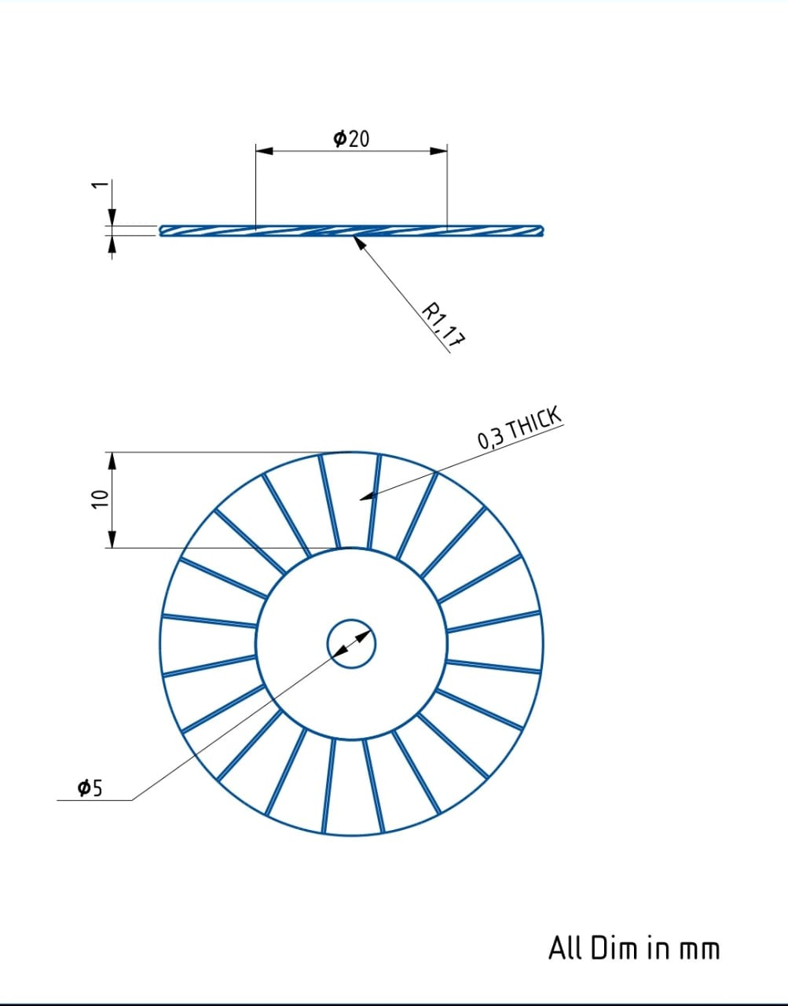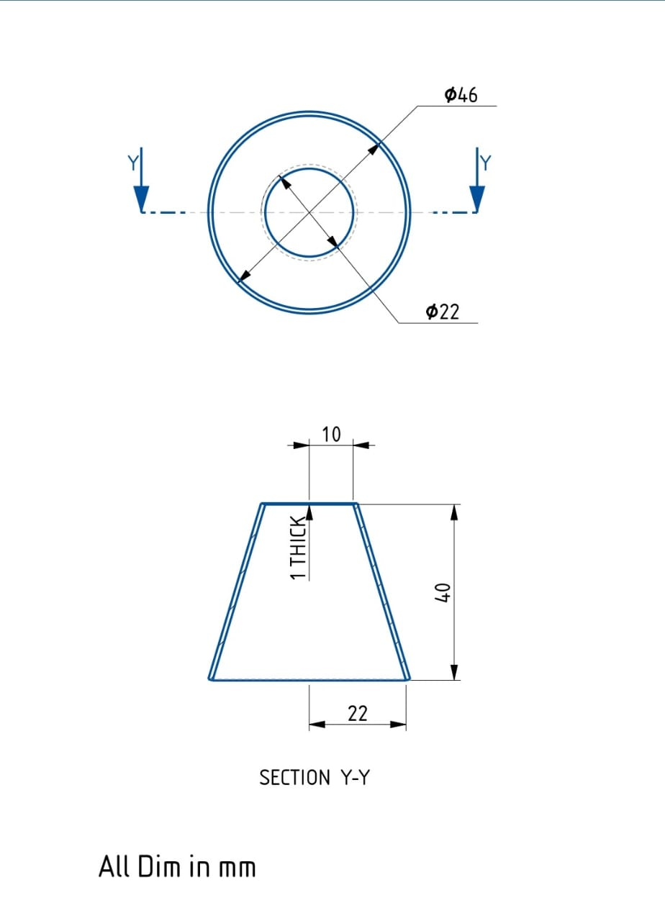

**fig 7.1 BLADE fig 7.2 CONE**

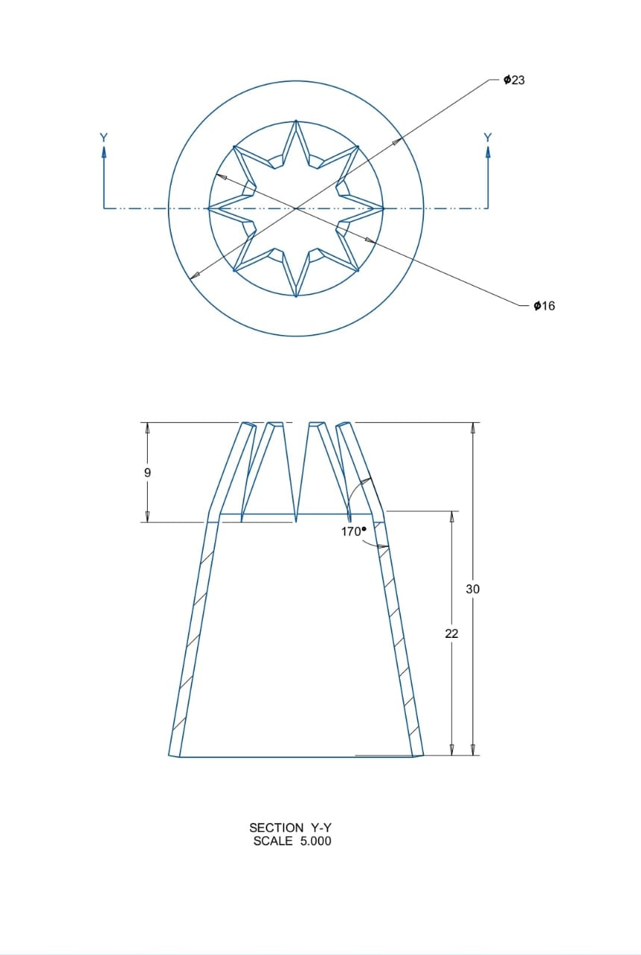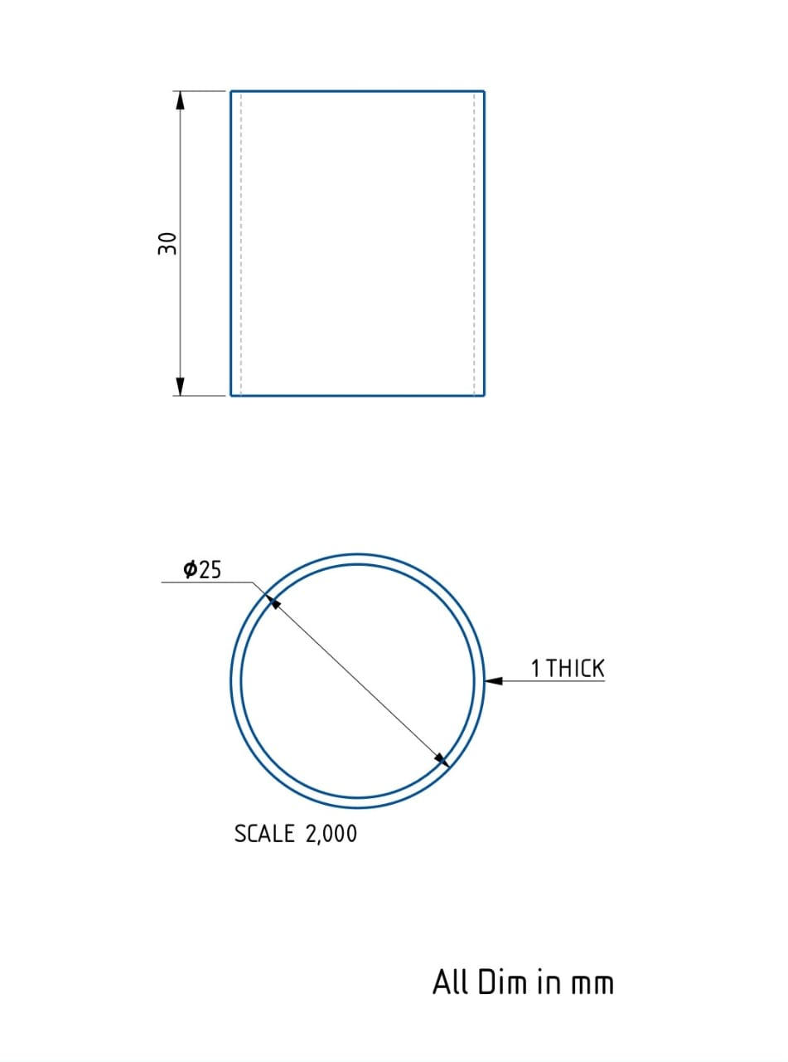

**fig7.3NOZZLE fig7.4OUTERBODY**

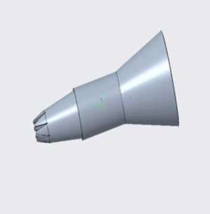 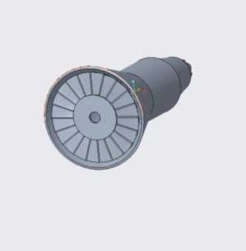

**fig7.4ASSEMBLY (1) fig7.5 ASSEMBLY (2)**

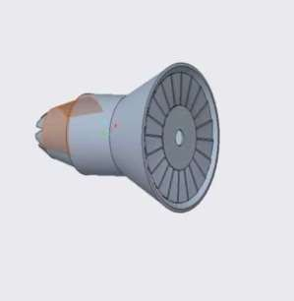

**fig7.6 ASSEMBLY (3)**

# CHAPTER 8FABRICATEDMODEL

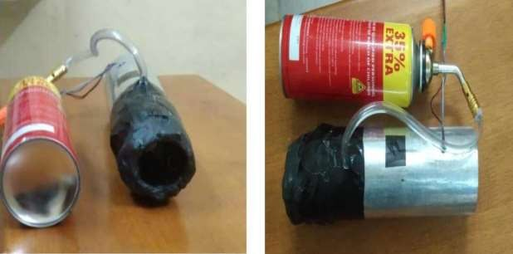

**fig8.1FRONT VIEW fig8.2 TOP VIEW**

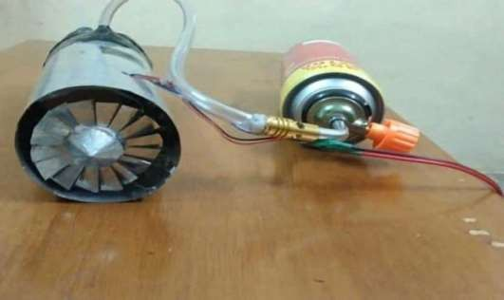

# fig8.3 BACK END

## CHAPTER9

## COSTESTIMATION

|  |  |  |
| --- | --- | --- |
| **SLNO** | **PARTICLES** | **AMOUNT** |
| 1 | MATERIALCOST | 1600 |
| 2 | WELDING | 500 |
| 3 | DRILLING | 400 |
| 4 | MANUFACTURINGCOST | 500 |
| 5 | DOCUMENTATION | 250 |
| 6 | OTHERALLOWANCES | 500 |
|  | TOTALCOST | 3750 |

# CHAPTER 10BIBLIOGRAPHY

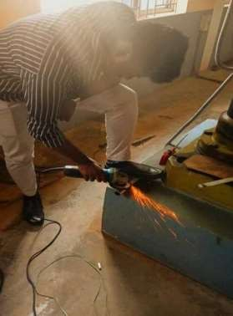

**fig10.1GRINDING**

The following links are used as a references for finishing and achieving good finish for the project which is fabricated.

Welding Tips and Tricks:

* <https://www.weldingtipsandtricks.com>
* Offers hands-on advice and video tutorials for welding practitioners.

Machining Doctor:

* [https://www.machiningdoctor.com•](https://www.machiningdoctor.com#)
* Offers practical insights into grinding processes and tools

**CHAPTER 11WORKINGPRINCIPLES**

The working principle of a ship turbo booster revolves around the enhancementof propulsion efficiency through the conversion and amplification of energy within thepropulsion system.Turbo boostersoperateby harnessing the energy from exhaustgasesoranexternalpowersourceandredirectingittoprovideadditionalthrust,enablingshipstoachievehigherspeeds andimprovedperformance.

## EnergyCollectionandConversion:

In turbo booster systems, energy is typically collected from the exhaust gasesemitted by the ship's primary engine. These exhaust gases contain high levels of kineticand thermal energy, which would otherwise be wasted. The turbo booster utilizes thisenergy by channeling it through a turbine system. The turbine converts the thermalenergy of the exhaust gases into mechanical energy, which drives a compressor oradditionalpropulsionmechanism.

## CompressionandThrustGeneration:

The mechanical energy generated by the turbine is used to compress incomingair, increasing its density and pressure. This compressed air is then introduced into theengine's combustion chamber or a secondary propulsion system. The enhanced airpressure improves the combustion process, resulting in a more powerful thrust output.In some systems, the turbo booster directly powers an auxiliary propeller or jet systemtoprovideadditionalthrust.

## SmartControlSystems:

Modernshipturboboostersareequippedwithintelligentcontrolsystemsthat

monitorandadjusttheoperationinreal-time.Sensorsmeasurekeyparameterssuchas

engine speed, exhaust temperature, and air pressure to optimize the performance oftheturbobooster.Thesesystemsensureefficientenergyutilization,preventoverheating,andmaintainthereliabilityofthe propulsionsystem.

## ThermalManagement:

Effectivethermalmanagementisacriticalaspectoftheworkingprinciple. Turbo

boostersareexposedtoextremetemperaturesdue tothe high-energyexhaustgases.Advancedcoolingmechanisms,suchasliquidcoolingorheat-resistantmaterials,areusedtomaintainoptimaloperatingconditionsandpreventdamageto thesystem.

## Integration withHybridSystems:

Insomeapplications,shipturboboostersareintegratedwithhybridpropulsionsystems,combiningtraditionalengineswithelectricoralternativeenergysources.Theturboboosteramplifiesthepropulsioncapacityofthesesystems,enablinggreaterefficiencyandoperationalflexibility.

## CHAPTER12RESULT

The results of using turbo boosters extend beyond commercial and militaryapplications,findingrelevanceinexplorationandresearchinitiatives.Thedeployment of ship turbo booster results in a significant increase in the speed andefficiency of maritime and aerospace vessels. By providing additional thrust, thesesystemsenableshipstocoverlongerdistancesinshorterperiods,reducingoperational delaysandimproving overallproductivity.In theaerospacesector,turbo boosters have proven essential for achieving key mission objectives, such asorbital adjustments, docking operations, and interplanetary travel. It provides rapidresponse,increasedmaneuverability,operationalflexibility,reliability.Theadvantages of ship turbo booster make hybrid propeller ships highly effective innavigating challenging maritime environments and responding to emergencies likecyclones.

## CHAPTER 13CONCLUSION

A gas turbine operates by converting chemical energy from fuel into mechanicalenergythroughaprocessinvolvingaircompression,fuelcombustion,andtheexpansion of high-temperature gases. The cycle starts with air being compressed toincrease its pressure and temperature. This compressed air is then mixed with fuel andignited,producinghigh-temperature,high-pressuregases.

These gases expand rapidly, passing through the turbine and causing it to spin,whichgeneratesmechanicalenergy.Thisenergycanbeusedtodriveelectricalgeneratorsorpropelvehicles,includingships.

Inmaritimeapplications,gasturbinesareintegratedintohybridpropulsionsystems, providing additional thrust and power when needed. They are particularlyvaluable in emergency situations, such as navigating through cyclones, due to theirability to deliver high power quickly and enhance maneuverability. The combinationof gas turbinesand diesel enginesallowsshipsto switch between power sourcesoruse both simultaneously, optimizing performance and efficiency while ensuring safetyand reliability under various conditions. This hybrid approach leverages the quickstart-up and high power-to-weight ratio of gas turbines, making them ideal for modernnavalandcommercialvessels.

A propeller works by converting rotational energy from an engine into thrust,which propels a ship through the water. When the propeller spins, its blades interactwith the water to create a pressure difference: high pressure behind the blades and lowpressure in front of them. This pressure differential generates thrust, pushing the shipforward. The design of the blades, including their shape and angle, is crucial forefficientpropulsionandminimizingdrag.

In maritime applications, propellers are the primary means of propulsion forvarious types of vessels, from small boats to large ships. They are connected to theship's engine or motor via a shaft, which transmits the rotational energy needed tospin the propeller. The size and design of the propeller are tailored to the specificrequirementsofthevessel,ensuringoptimalperformanceandfuelefficiency.Propellerscan alsobepartofmoreadvancedpropulsionsystems,likehybridsetupsthatcombinedieselenginesandgasturbines,providingflexibility andenhancedmaneuverability,especiallyinchallengingconditionslikecyclones.

Integrating gas turbines into the propulsion systems of ships provides a robustsolutionformodernmaritimechallenges.Thehybridapproachmaximizesthestrengths of both diesel engines and gas turbines, ensuring efficiency, reliability,and enhanced performance in both regular and emergency operations. The carefulselection of materials like stainless steel for critical components further ensures thesystem's durability and reliability.This innovative propulsion system is essentialfor improving the safety and efficiency of marine vessels, especially in the face ofunpredictable maritime conditions such as cyclones. Its application is crucial innaval defense, commercial shipping, and other maritime industries, setting a newstandardformarineengineeringandoperations.

As thetechnologycontinuestoevolve,theshipturboboosterpromisestoredefinethe standards ofmoderntransportationandexploration.Bypushingtheboundaries of performance and sustainability, it establishes a foundation for futureadvancements,pavingthewayformoreefficient,reliable,andenvironmentallyconsciouspropulsionsystems.Theshipturboboosterisnotmerelyanenhancement to existing systems but a transformative step towards a more dynamicandinnovativefutureinglobaltransportation.

Moreover, turbo boosters drive innovation through the integration of advancedmaterials, smart control systems, and thermal management technologies, setting newbenchmarks for durability, adaptability, and operational precision. Their applicationsspan commercial, military, and exploratory domains, underscoring their versatilityandbroadutility.

# CHAPTER 14REFERENCES

* + 1. **Books:** "Marine Propellers and Propulsion" by John Carlton. "Turbo charging the Internal Combustion Engine" by T. H. H. Lee.
    2. **Research Papers:** "Performance Analysis of Turbocharged Marine Engines. "Impact of Turbo Boosting on Ship Efficiency" (Journal of Marine Science and Technology).
    3. **Journal Articles:** Turbocharger Design for Marine Diesel Engines" by A. Singh et al., presented at the International Conference on Marine Engineering, 2017.
    4. **Online Resources:** "Turbocharger Basics" by Cummins Inc., 2020.
    5. **Books:** "Turbocharging the Internal Combustion Engine" by N. Watson and M. S. Janota, published by Wiley, 2017.